The University of Azad Jammu and Kashmir, Muzaffarabad

Name: Alishba Zakir
Roll No: 2024-SE-02
Course: DataBase Systems
Course Code: CS-2204
Lab: 04
Submitted To: Engr. Awais Rathore
Submitted By: Alishba Zakir
Date: Mar, 2026

Department Of Software Engineering
Normalization Overview &1NF
Normalization:
Database normalization is the systematic process of organizing fields and tables of a relational database to minimize data redundancy and eliminate data anomalies (insertion, update, and deletion errors). It involves breaking a large, bloated table into smaller, well-structured tables and linking them using relationships.
Task 1— Identify FDs and Anomalies:
1. Functional Dependency (FD)
A functional dependency (\(X \rightarrow Y\)) means if you know the value of X, you can uniquely determine the value of Y. The attribute \(X\) acts as the map or key to find \(Y\).
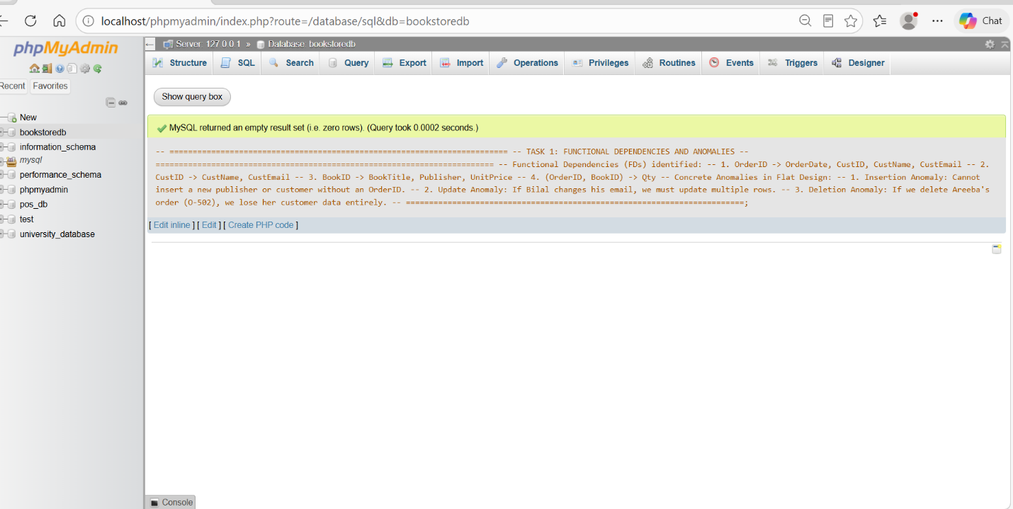

Anomalies are data errors or unexpected bugs that happen when you insert, change, or delete data in an unnormalized flat table.
- Insertion Anomaly: You cannot add new information because it requires other missing data. Example: You cannot add a new publisher until someone buys their book.
- Update Anomaly: Changing a single fact requires updating multiple duplicate rows. Example: If a customer changes their email, you must edit every single order row they ever made.
- Deletion Anomaly: Deleting a row to remove one fact accidentally destroys an entirely unrelated fact. Example: If you delete a customer's cancelled order, you permanently lose that customer's profile data.
Task 2 — Convert to 1NF:
The Rule of 1NF
A table is in 1NF if and only if every cell contains a single, atomic value. This means:
- No multi-valued cells (e.g., no items separated by commas or semicolons within a single box).
- No repeating groups or hidden nested lists.
- Every row must be uniquely identifiable using a primary key.

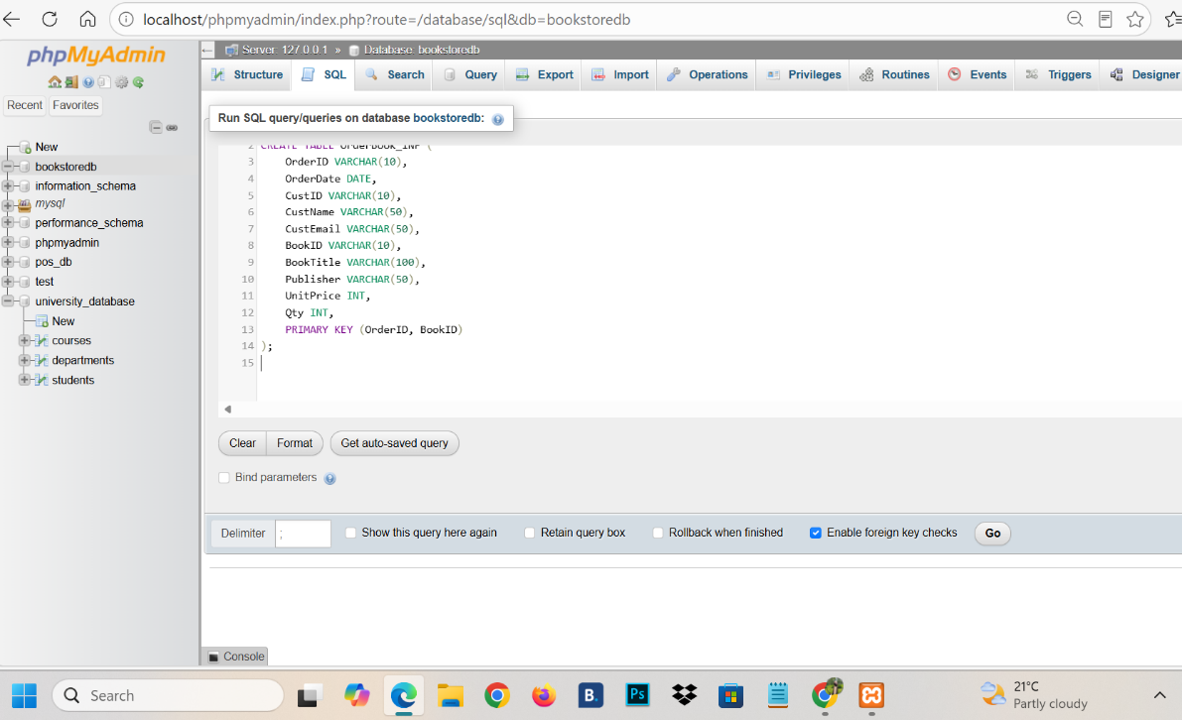

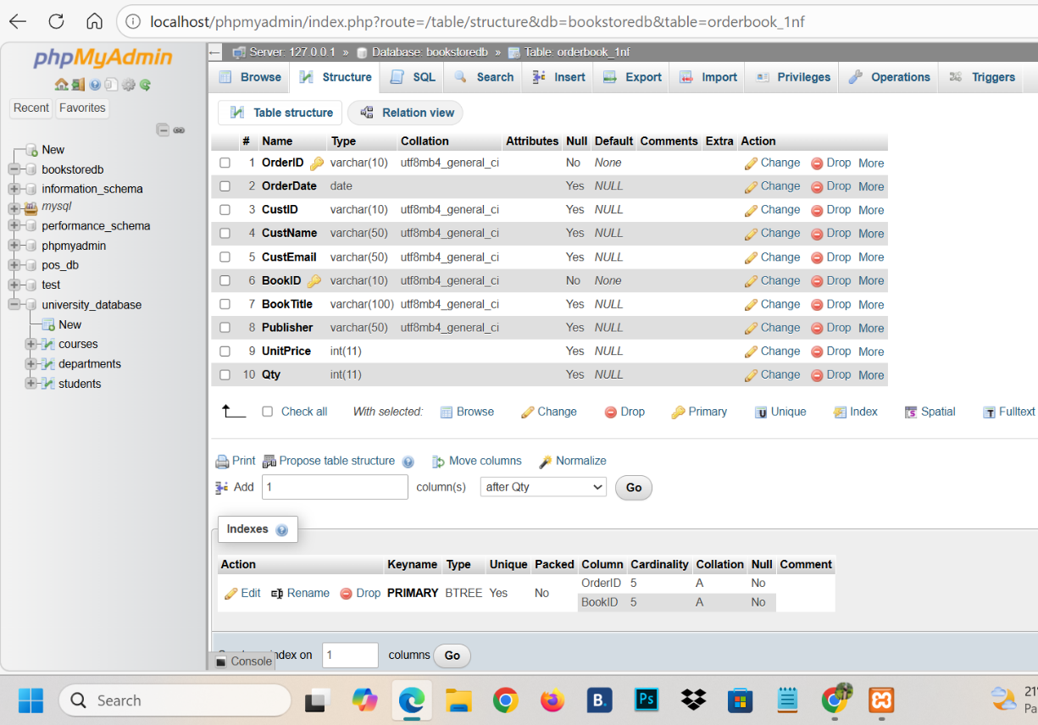

- Inserting Data into 1NF

